ANALYSIS ON STRONG COMPONENTS

Problem Statement:
Run experiment to determine empirically the distribution of the number of strong components in random digraphs of various types, by generating large number of digraphs and drawing a histogram.

Explanation of the problem statement:
A graph is said to be strongly connected or disconnected based on the reachability of vertices.
We need to generate all types of graphs and have to know how many strongly connected graphs are formed and to what extent the graphs can be taken as input (i.e for how many graphs we can generate the strongly connected components at a time).
To find strong components in the graph there are many algorithms but I have used Kosaraju - Sharir - SCC algorithm. Strong components can be found out only if the graph is connected strongly.
We also need to specify the histogram representation of the strongly connected components obtained for each graph(i.e. the result for the count of the strong components).

Analysis:
There are many types of digraphs developed. Initially we need to generate the digraphs of all types for the given number of vertices and edges. So I have taken the vertices and edges as input . And also calculate the number of edges which will be obtained for the given number of vertices and used the digraph generator to form the digraphs.
Each time the vertices and the edges are sent to the digraph and the digraphs are created and returned to us.
For the analysis purpose the time complexities for the worst cases of the vertices and the edges given as input are shown below in the form of a table :

S.NO | Vertices and Edges | Time complexity (Worst case)
1) | V = 10; E = 25 | O(V + E) = O(10 + 25) = O(35)
2) | V = 10; E = 12 | O(V + E) = O(10 + 12) = O(22)
3) | V = 100; E = 250 | O(V + E) = O(100 + 250) = O(350)
4) | V = 100; E = 125 | O(V + E) = O(100 + 125) = O(135)
5) | V = 1000; E = 2500 | O(V + E) = O(1000 + 2500) = O(3500)
6) | V = 1000; E = 1250 | O(V + E) = O(1000 + 1250) = O(1350)

We can also conclude that the time is directly proportional to the vertices and the edges. If we increase the count of the vertices and edges the time complexity also increases accordingly.
Taking this into consideration the Standard Brute force algorithm time complexity increases.As its time complexity is O(V^2*E) which is more than Kosaraju - Sharir _ SCC algorithm. So it is more efficient and best to use the Kosaraju - Sharir - SCC algorithm to find out the Strong components.
The obtained Digraphs are sent to the Kosaraju - Sharir - SCC algorithm and the strong connected components and calculated and returned as output from it.

CODE Link(GIT HUB) :

Source Code

OUTPUTS Obtained:
- Vertices = 10 ;
Edges = 12;
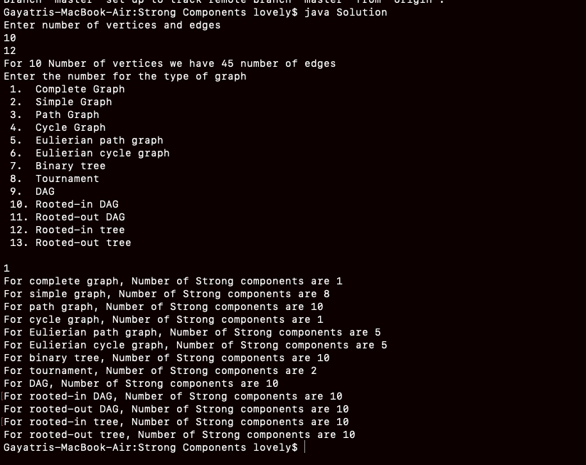
2) For 100 vertices we get 4950 edges taking all of them into consideration the strongly connected components are:
Vertices : 100; Edges : given 23 but actually computed to 4950.
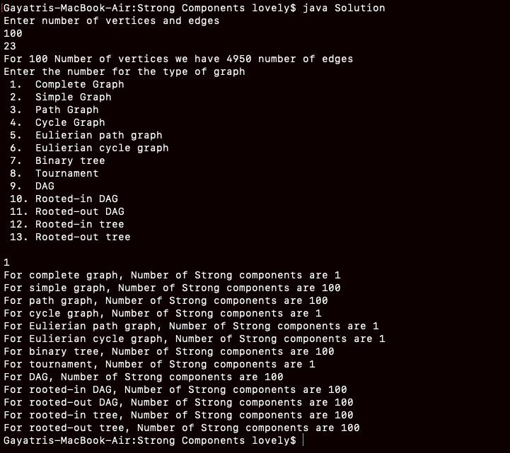

3) For 1000 vertices we get 499500 edges taking all of them into consideration the strongly connected components are:
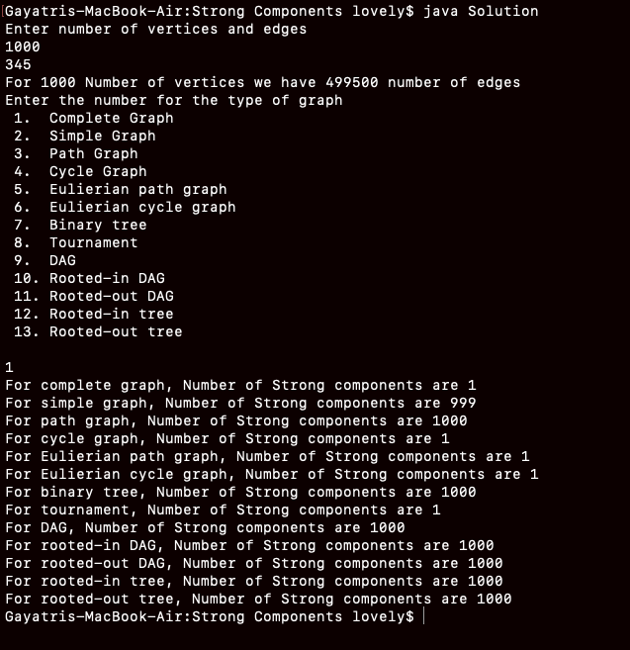
Vertices : 1000; Edges : given 345 but actually computed to 499500.

Exceptional Case:
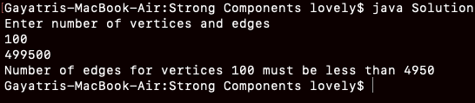
If the edges obtained for the given vertices are entered more than that. It will raise an error that it should not exceed the limit of the edges count to be obtained. According to the formula calculated for obtaining the edges.

FULL HISTOGRAM:
